# API testing

APIs (Application Programming Interfaces) enable software systems and applications to communicate and share data. API testing is important as vulnerabilities in APIs may undermine core aspects of a website's confidentiality, integrity, and availability.

All dynamic websites are composed of APIs, so classic web vulnerabilities like SQL injection could be classed as API testing. In this topic, we'll teach you how to test APIs that aren't fully used by the website front-end, with a focus on RESTful and JSON APIs. We'll also teach you how to test for server-side parameter pollution vulnerabilities that may impact internal APIs.

To illustrate the overlap between API testing and general web testing, we've created a mapping between our existing topics and the [OWASP API Security Top 10 2023](https://portswigger.net/web-security/api-testing/top-10-api-vulnerabilities).

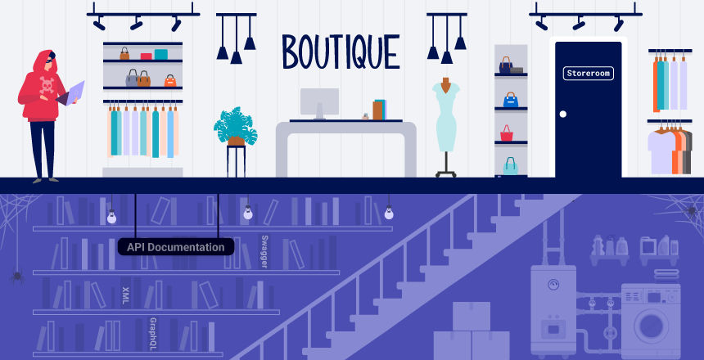

# API recon

To start API testing, you first need to find out as much information about the API as possible, to discover its attack surface.

To begin, you should identify API endpoints. These are locations where an API receives requests about a specific resource on its server. For example, consider the following GET request:

GET /api/books HTTP/1.1   
Host: example.com

The API endpoint for this request is /api/books. This results in an interaction with the API to retrieve a list of books from a library. Another API endpoint might be, for example, /api/books/mystery, which would retrieve a list of mystery books.

Once you have identified the endpoints, you need to determine how to interact with them. This enables you to construct valid HTTP requests to test the API. For example, you should find out information about the following:

* The input data the API processes, including both compulsory and optional parameters.
* The types of requests the API accepts, including supported HTTP methods and media formats.
* Rate limits and authentication mechanisms.

# API documentation

APIs are usually documented so that developers know how to use and integrate with them.

Documentation can be in both human-readable and machine-readable forms. Human-readable documentation is designed for developers to understand how to use the API. It may include detailed explanations, examples, and usage scenarios. Machine-readable documentation is designed to be processed by software for automating tasks like API integration and validation. It's written in structured formats like JSON or XML.

API documentation is often publicly available, particularly if the API is intended for use by external developers. If this is the case, always start your recon by reviewing the documentation.

## Discovering API documentation

Even if API documentation isn't openly available, you may still be able to access it by browsing applications that use the API.

To do this, you can use Burp Scanner to crawl the API. You can also browse applications manually using Burp's browser. Look for endpoints that may refer to API documentation, for example:

* /api
* /swagger/index.html
* /openapi.json

If you identify an endpoint for a resource, make sure to investigate the base path. For example, if you identify the resource endpoint /api/swagger/v1/users/123, then you should investigate the following paths:

* /api/swagger/v1
* /api/swagger
* /api

You can also use a list of common paths to find documentation using Intruder.

LAB

APPRENTICE [Exploiting an API endpoint using documentation](https://portswigger.net/web-security/api-testing/lab-exploiting-api-endpoint-using-documentation)

To solve the lab, find the exposed API documentation and delete carlos. You can log in to your own account using the following credentials: wiener:peter.

**Solution:**

1. Log in using the credentials wiener:peter and update your email address.
2. Capture PATCH /api/user/wiener request and select **Send to Repeater**.
3. Go to the **Repeater** tab. Send the PATCH /api/user/wiener request. Notice that this retrieves credentials for the user wiener.
4. Remove /wiener from the path of the request, so the endpoint is now /api/user, then send the request. Notice that this returns an error because there is no user identifier.
5. Remove /user from the path of the request, so the endpoint is now /api, then send the request. Notice that this retrieves API documentation.   
   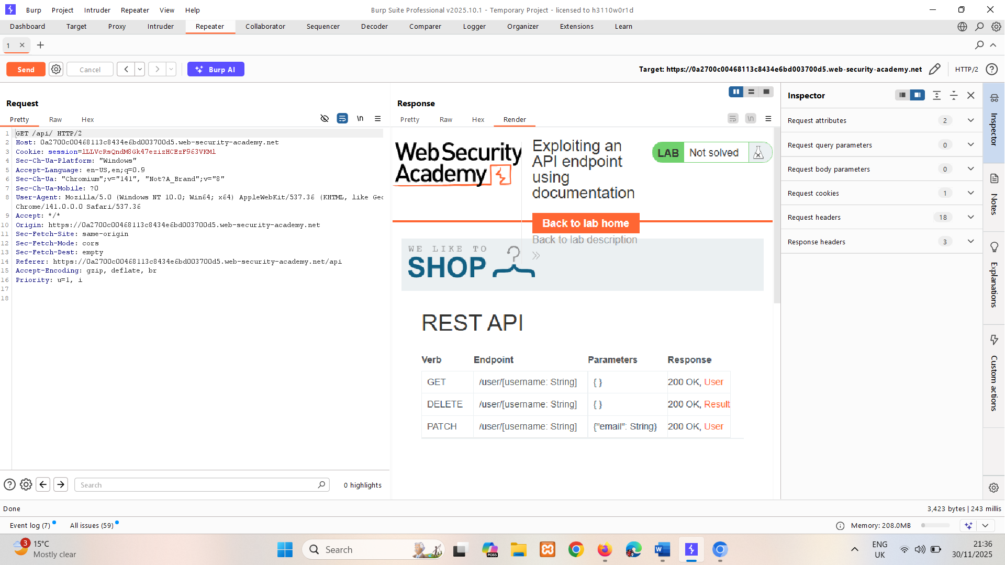
6. Type in browser /api  
   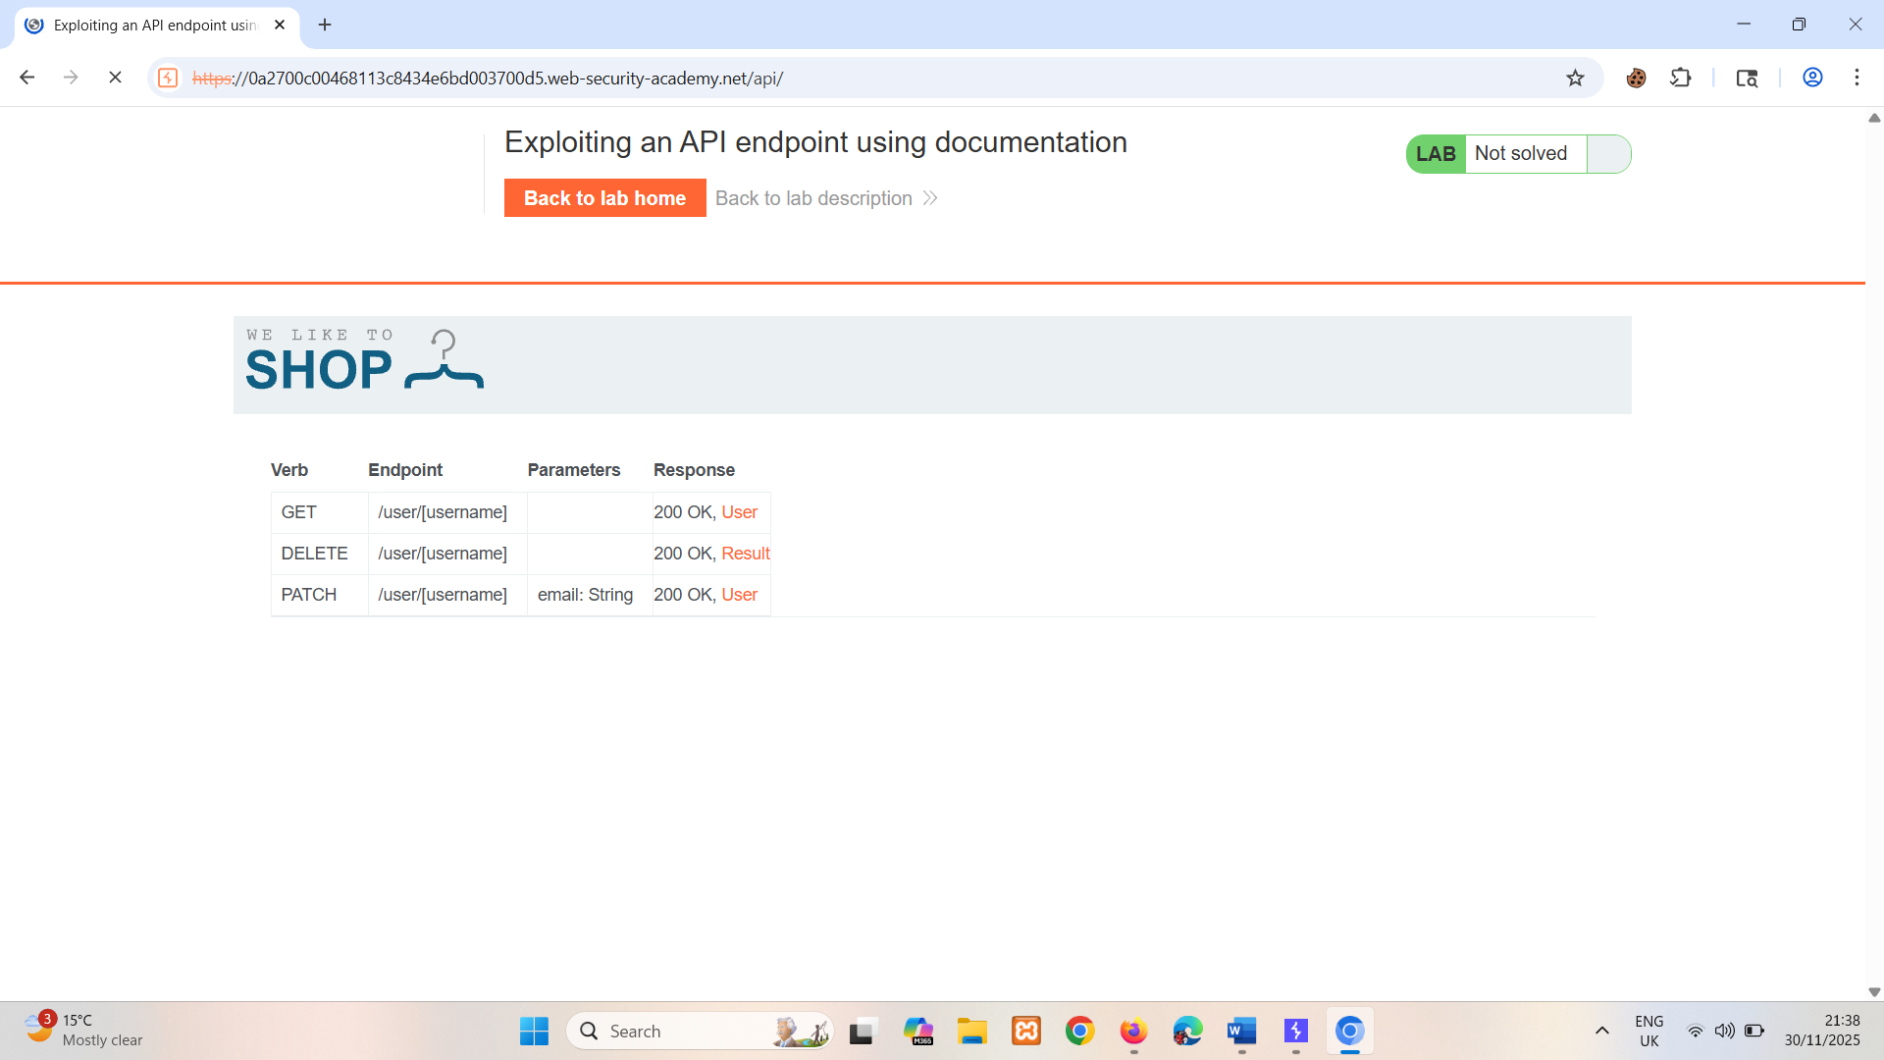Notice that the documentation is interactive.
7. To delete Carlos and solve the lab, click on the DELETE row, enter carlos, then click **Send request**.   
   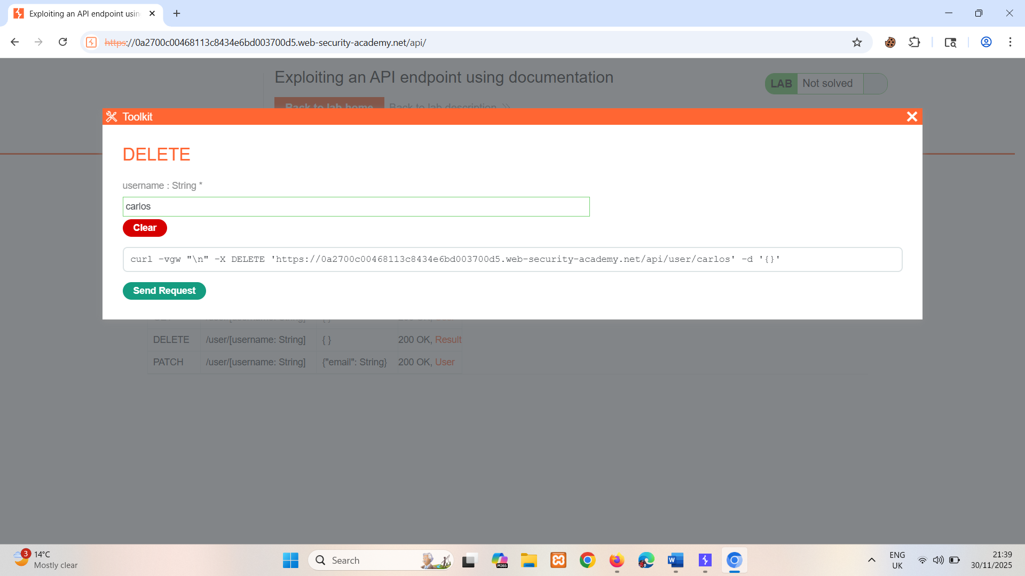

OR  
  
In burp change request to DELETE and remove json params also change username to carlos  
DELETE api/user/carlos

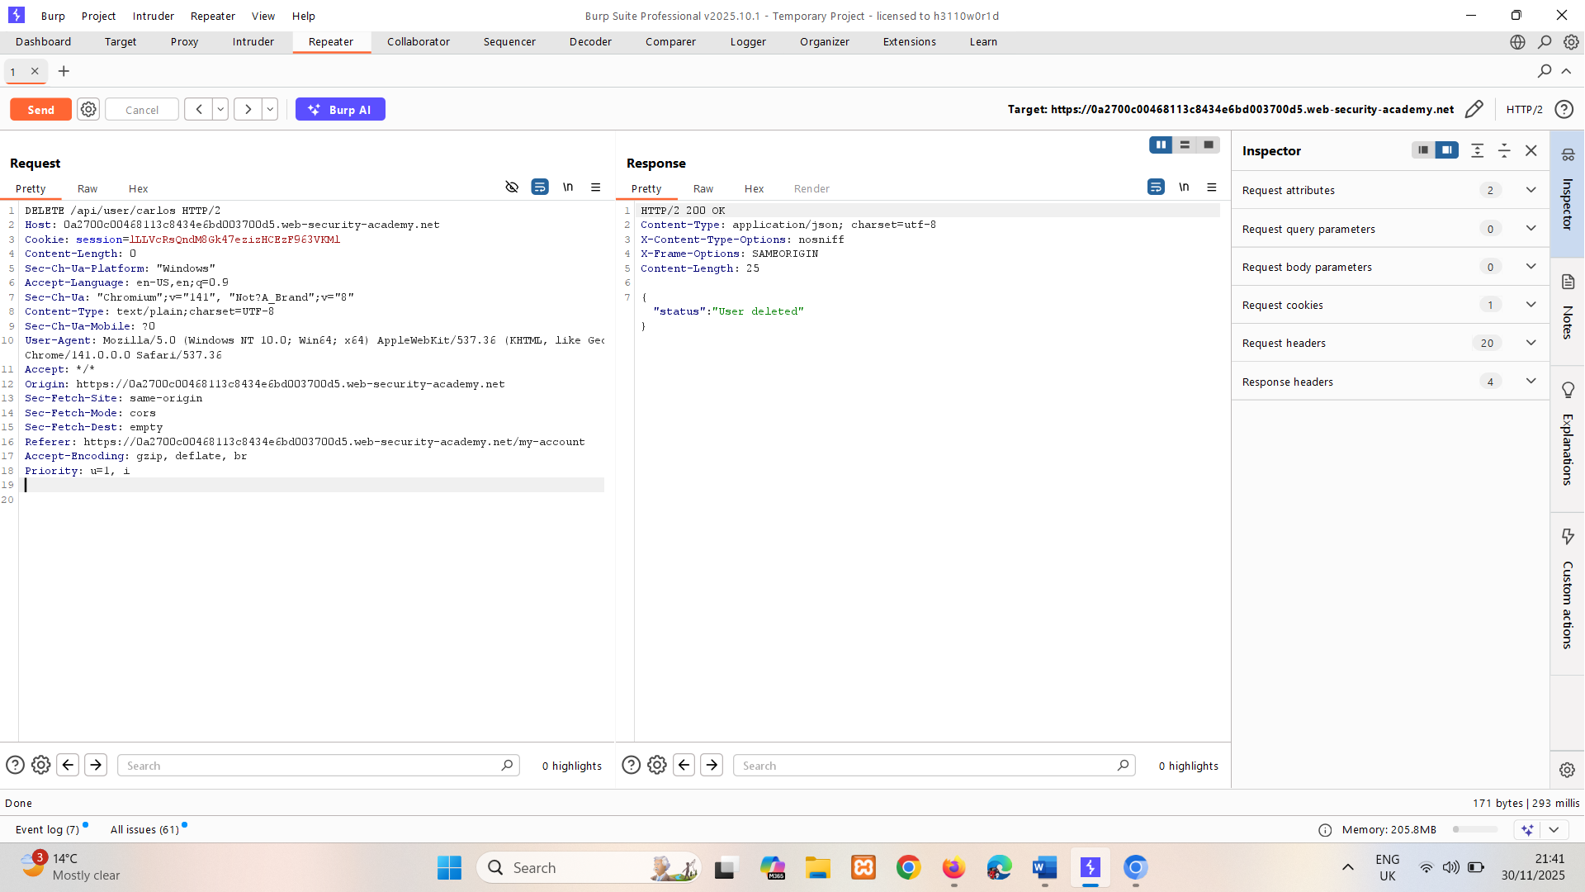

## Using machine-readable documentation

You can use a range of automated tools to analyze any machine-readable API documentation that you find.

You can use Burp Scanner to crawl and audit OpenAPI documentation, or any other documentation in JSON or YAML format. You can also parse OpenAPI documentation using the [OpenAPI Parser](https://portswigger.net/bappstore/6bf7574b632847faaaa4eb5e42f1757c) BApp.

You may also be able to use a specialized tool to test the documented endpoints, such as [Postman](https://www.postman.com/) or [SoapUI](https://www.soapui.org/).

# Identifying API endpoints

You can also gather a lot of information by browsing applications that use the API. This is often worth doing even if you have access to API documentation, as sometimes documentation may be inaccurate or out of date.

You can use Burp Scanner to crawl the application, then manually investigate interesting attack surface using Burp's browser.

While browsing the application, look for patterns that suggest API endpoints in the URL structure, such as /api/. Also look out for JavaScript files. These can contain references to API endpoints that you haven't triggered directly via the web browser. Burp Scanner automatically extracts some endpoints during crawls, but for a more heavyweight extraction, use the [JS Link Finder](https://portswigger.net/bappstore/0e61c786db0c4ac787a08c4516d52ccf) BApp. You can also manually review JavaScript files in Burp.

## Interacting with API endpoints

Once you've identified API endpoints, interact with them using Burp Repeater and Burp Intruder. This enables you to observe the API's behavior and discover additional attack surface. For example, you could investigate how the API responds to changing the HTTP method and media type.

As you interact with the API endpoints, review error messages and other responses closely. Sometimes these include information that you can use to construct a valid HTTP request.

### Identifying supported HTTP methods

The HTTP method specifies the action to be performed on a resource. For example:

* GET - Retrieves data from a resource.
* PATCH - Applies partial changes to a resource.
* OPTIONS - Retrieves information on the types of request methods that can be used on a resource.

An API endpoint may support different HTTP methods. It's therefore important to test all potential methods when you're investigating API endpoints. This may enable you to identify additional endpoint functionality, opening up more attack surface.

For example, the endpoint /api/tasks may support the following methods:

* GET /api/tasks - Retrieves a list of tasks.
* POST /api/tasks - Creates a new task.
* DELETE /api/tasks/1 - Deletes a task.

You can use the built-in **HTTP verbs** list in Burp Intruder to automatically cycle through a range of methods.

**Note**

When testing different HTTP methods, target low-priority objects. This helps make sure that you avoid unintended consequences, for example altering critical items or creating excessive records.

### Identifying supported content types

API endpoints often expect data in a specific format. They may therefore behave differently depending on the content type of the data provided in a request. Changing the content type may enable you to:

* Trigger errors that disclose useful information.
* Bypass flawed defenses.
* Take advantage of differences in processing logic. For example, an API may be secure when handling JSON data but susceptible to injection attacks when dealing with XML.

To change the content type, modify the Content-Type header, then reformat the request body accordingly. You can use the [Content type converter](https://portswigger.net/bappstore/db57ecbe2cb7446292a94aa6181c9278) BApp to automatically convert data submitted within requests between XML and JSON.

LAB

PRACTITIONER [Finding and exploiting an unused API endpoint](https://portswigger.net/web-security/api-testing/lab-exploiting-unused-api-endpoint)

To solve the lab, exploit a hidden API endpoint to buy a **Lightweight l33t Leather Jacket**. You can log in to your own account using the following credentials: wiener:peter.

**Solution:**

1. Log into the lab, click on jacket and capture its GET /api/products/1/price request.
2. Change GET to OPTIONS and send request.  
     
   In response only GET and PATCH are allowed.

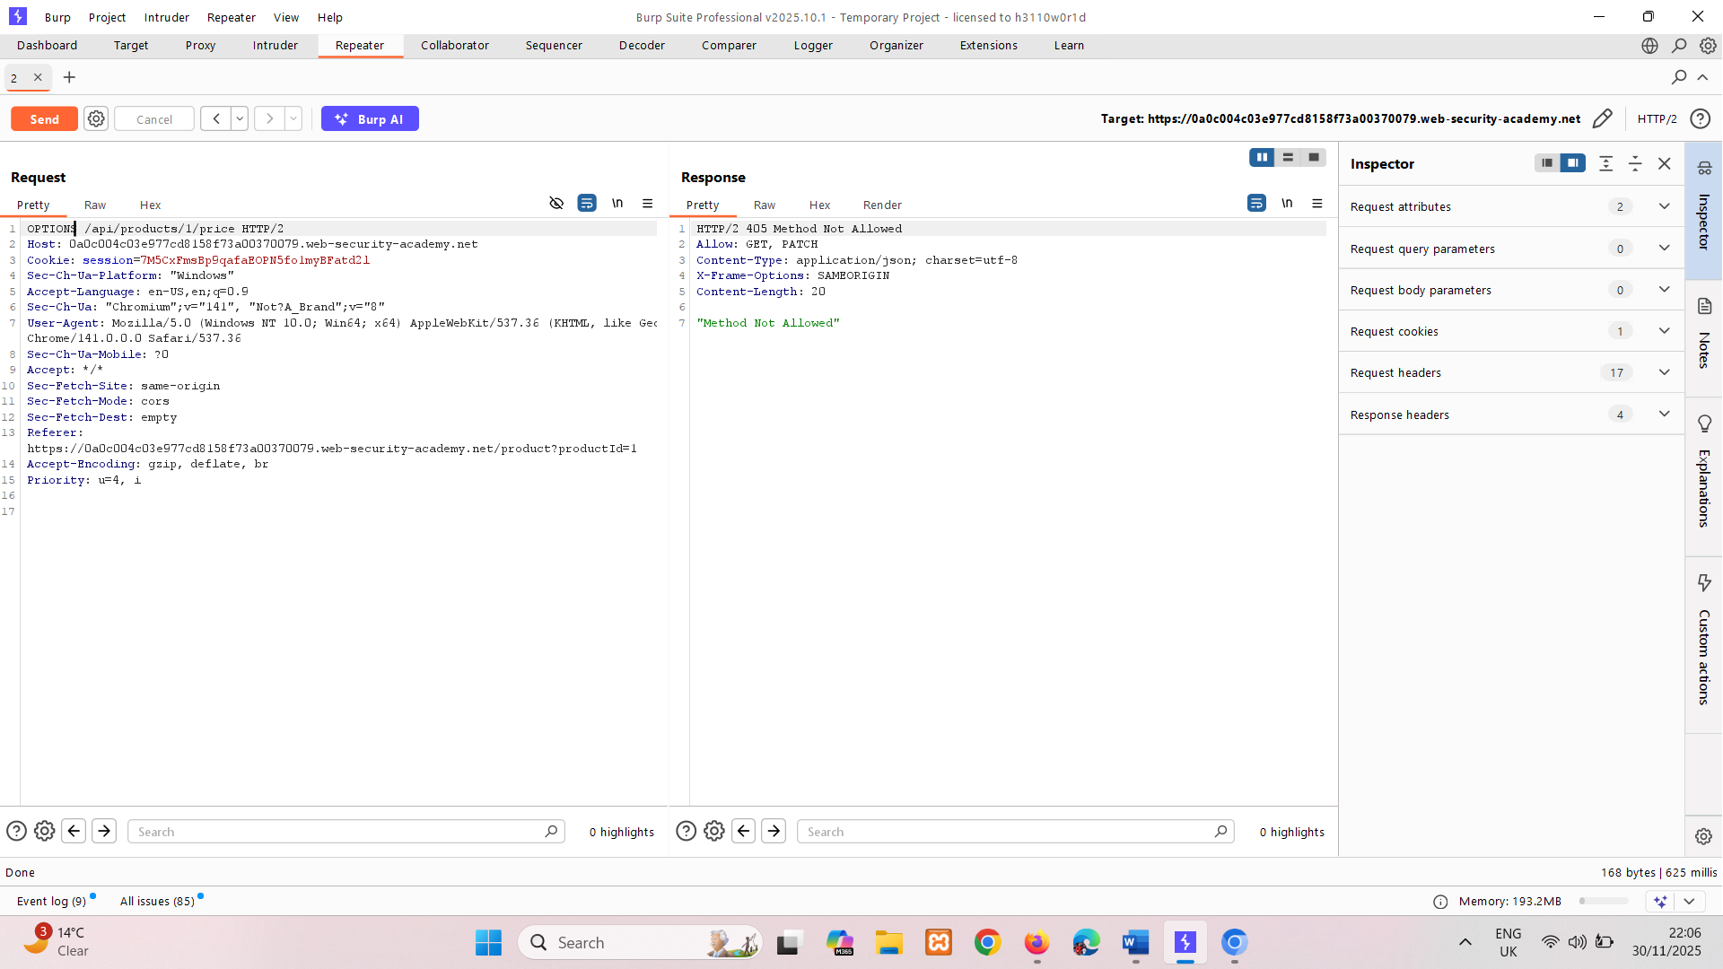

1. So change to PATCH.  
   It shows "error":"Only 'application/json' Content-Type is supported"

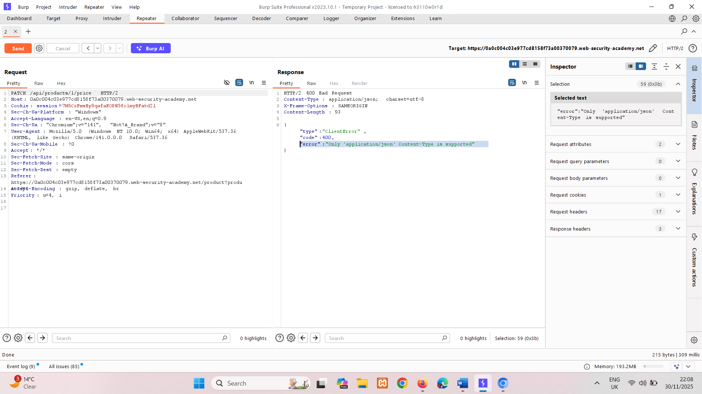

1. So change its content type to application/json.  
     
   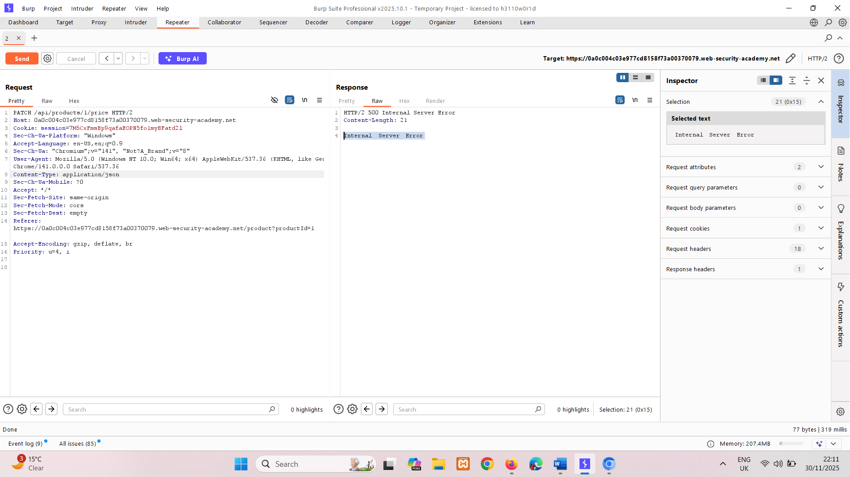  
   Giving internal server error cause JSON object {} request body is missing so add it.

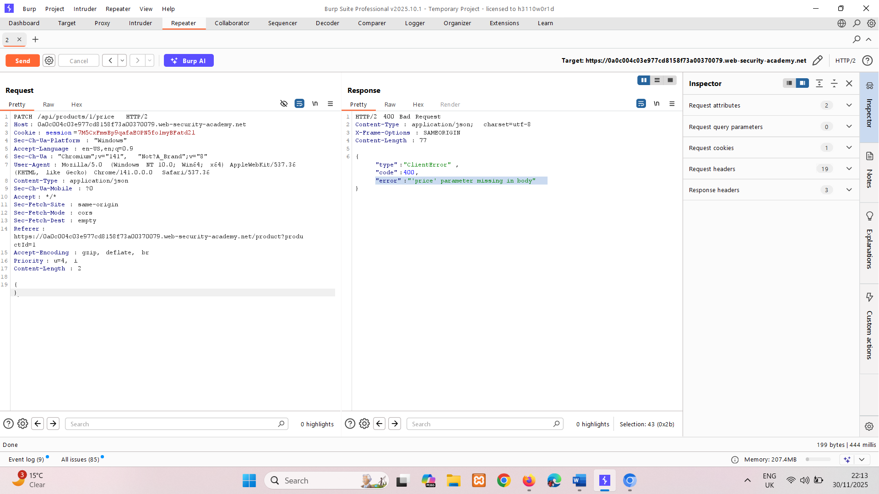  
Encountering "error":"'price' parameter missing in body"   
so add price parameter.  
{  
 "price":0  
}  
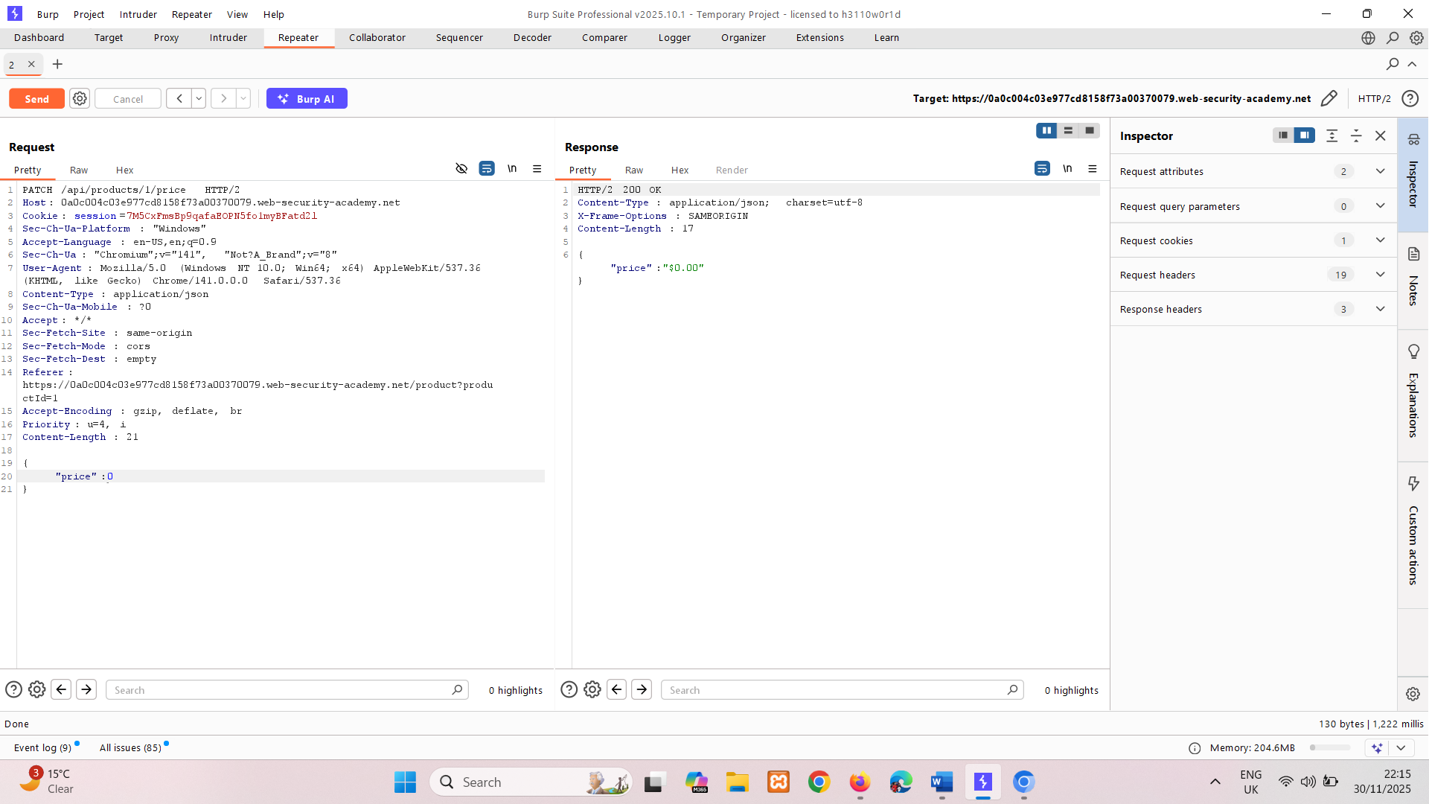  
And it’s done, price set to 0.

1. Refresh page, Add jacket to cart with 0 price and place the order.  
   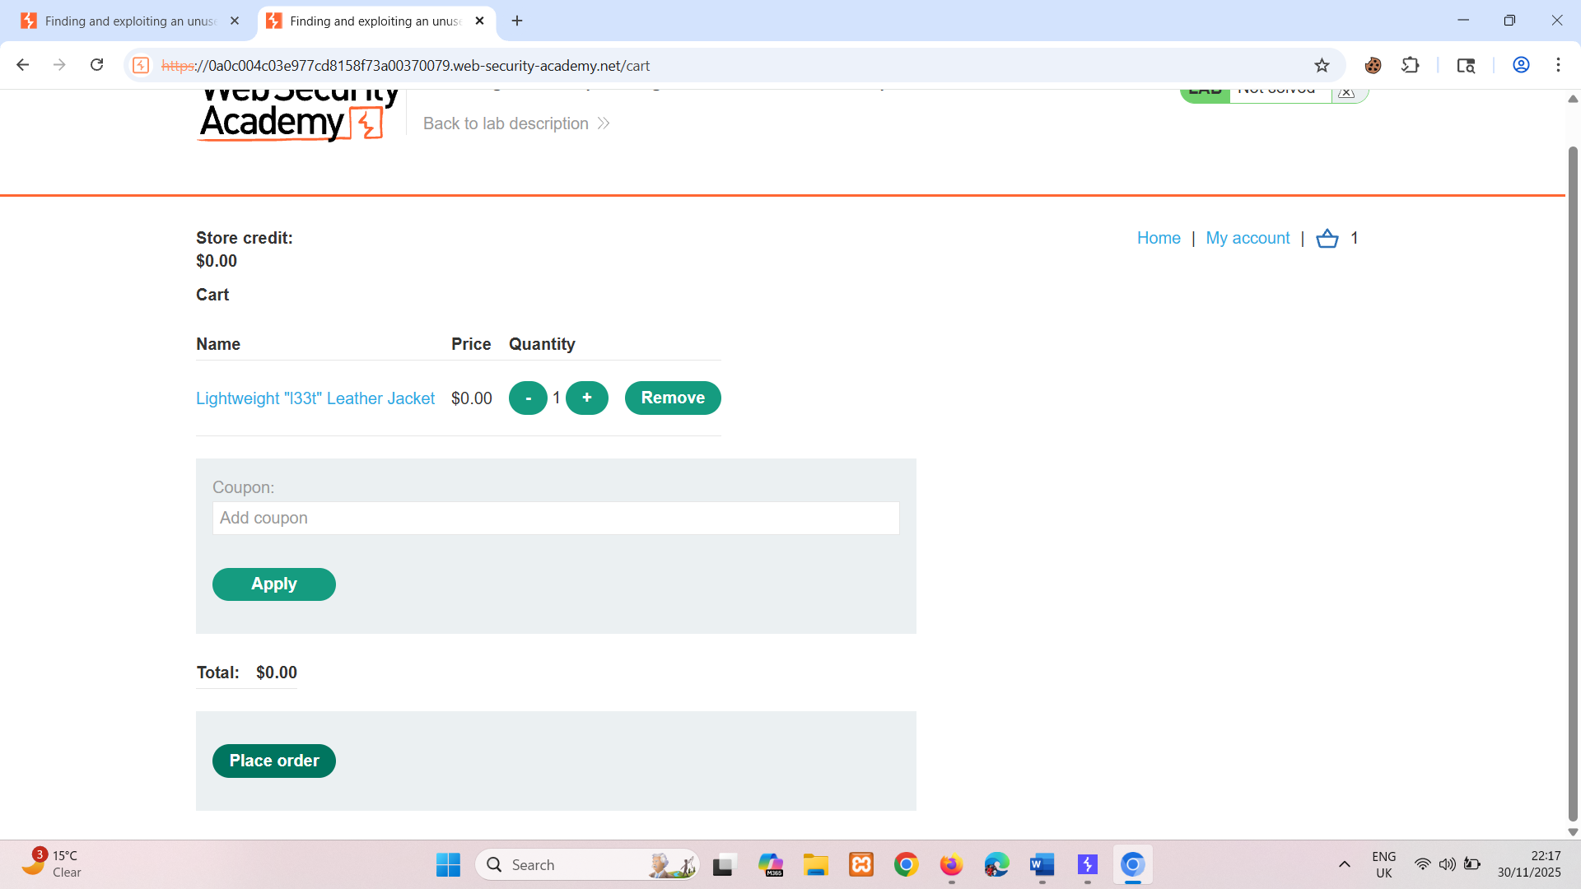

### Using Intruder to find hidden endpoints

Once you have identified some initial API endpoints, you can use Intruder to uncover hidden endpoints. For example, consider a scenario where you have identified the following API endpoint for updating user information:

PUT /api/user/update

To identify hidden endpoints, you could use Burp Intruder to find other resources with the same structure. For example, you could add a payload to the /update position of the path with a list of other common functions, such as delete and add.

When looking for hidden endpoints, use wordlists based on common API naming conventions and industry terms. Make sure you also include terms that are relevant to the application, based on your initial recon.

# Finding hidden parameters

When you're doing API recon, you may find undocumented parameters that the API supports. You can attempt to use these to change the application's behavior. Burp includes numerous tools that can help you identify hidden parameters:

* Burp Intruder enables you to automatically discover hidden parameters, using a wordlist of common parameter names to replace existing parameters or add new parameters. Make sure you also include names that are relevant to the application, based on your initial recon.
* The [Param miner](https://portswigger.net/bappstore/17d2949a985c4b7ca092728dba871943) BApp enables you to automatically guess up to 65,536 param names per request. Param miner automatically guesses names that are relevant to the application, based on information taken from the scope.
* The [Content discovery](https://portswigger.net/burp/documentation/desktop/tools/engagement-tools/content-discovery) tool enables you to discover content that isn't linked from visible content that you can browse to, including parameters.

## Mass assignment vulnerabilities

Mass assignment (also known as auto-binding) can inadvertently create hidden parameters. It occurs when software frameworks automatically bind request parameters to fields on an internal object. Mass assignment may therefore result in the application supporting parameters that were never intended to be processed by the developer.

### Identifying hidden parameters

Since mass assignment creates parameters from object fields, you can often identify these hidden parameters by manually examining objects returned by the API.

For example, consider a PATCH /api/users/ request, which enables users to update their username and email, and includes the following JSON:

{   
 "username": "wiener",   
 "email": "wiener@example.com",   
}

A concurrent GET /api/users/123 request returns the following JSON:

{   
 "id": 123, "name": "John Doe",   
 "email": "john@example.com",   
 "isAdmin": "false"   
}

This may indicate that the hidden id and isAdmin parameters are bound to the internal user object, alongside the updated username and email parameters.

### Testing mass assignment vulnerabilities

To test whether you can modify the enumerated isAdmin parameter value, add it to the PATCH request:

{   
 "username": "wiener",   
 "email": "wiener@example.com",   
 "isAdmin": false,   
}

In addition, send a PATCH request with an invalid isAdmin parameter value:

{   
 "username": "wiener",   
 "email": "wiener@example.com",   
 "isAdmin": "foo",   
}

If the application behaves differently, this may suggest that the invalid value impacts the query logic, but the valid value doesn't. This may indicate that the parameter can be successfully updated by the user.

You can then send a PATCH request with the isAdmin parameter value set to true, to try and exploit the vulnerability:

{   
 "username": "wiener",   
 "email": "wiener@example.com",   
 "isAdmin": true,   
}

If the isAdmin value in the request is bound to the user object without adequate validation and sanitization, the user wiener may be incorrectly granted admin privileges. To determine whether this is the case, browse the application as wiener to see whether you can access admin functionality.

LAB

PRACTITIONER [Exploiting a mass assignment vulnerability](https://portswigger.net/web-security/api-testing/lab-exploiting-mass-assignment-vulnerability)

To solve the lab, find and exploit a mass assignment vulnerability to buy a **Lightweight l33t Leather Jacket**. You can log in to your own account using the following credentials: wiener:peter.

**Solution:**

1. Log into the lab, click on jacket it hasn’t api request, try on change email still not,  
   add jacket to cart try to purchase it -> it has request /api/checkout capture it.
2. It also has interactive documentation at /api. Explore its functionalities.
3. Notice that in GET /api/checkout response It has Chosen discount so we can set   
   percentage to 100  
   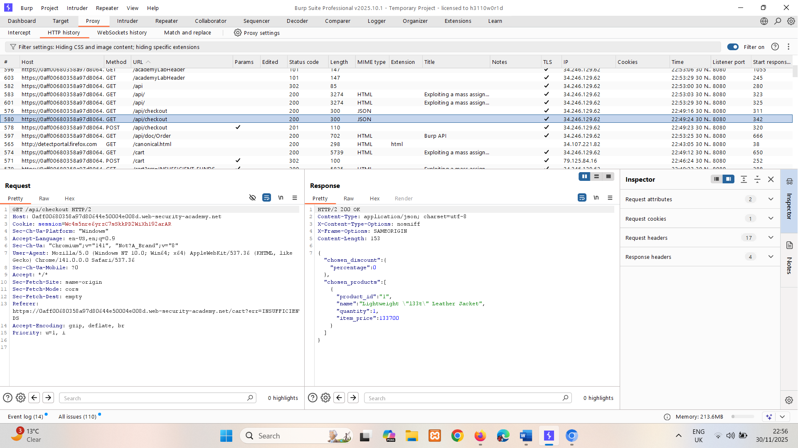
4. So send POST /api/checkout to repeater and add chosen discount  
   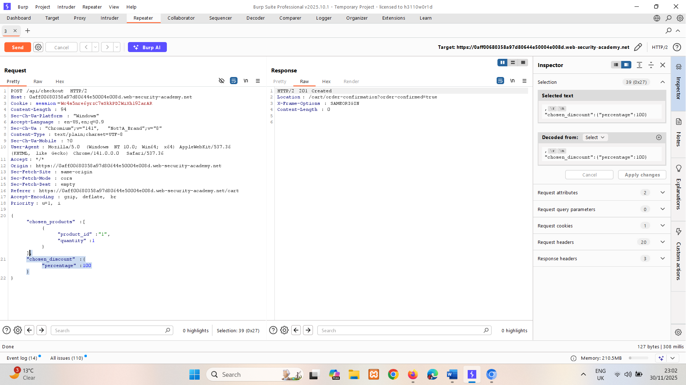

Discount is added to price. This solves lab.

# Preventing vulnerabilities in APIs

When designing APIs, make sure that security is a consideration from the beginning. In particular, make sure that you:

* Secure your documentation if you don't intend your API to be publicly accessible.
* Ensure your documentation is kept up to date so that legitimate testers have full visibility of the API's attack surface.
* Apply an allowlist of permitted HTTP methods.
* Validate that the content type is expected for each request or response.
* Use generic error messages to avoid giving away information that may be useful for an attacker.
* Use protective measures on all versions of your API, not just the current production version.

To prevent mass assignment vulnerabilities, allowlist the properties that can be updated by the user, and blocklist sensitive properties that shouldn't be updated by the user.

# Server-side parameter pollution

Some systems contain internal APIs that aren't directly accessible from the internet. Server-side parameter pollution occurs when a website embeds user input in a server-side request to an internal API without adequate encoding. This means that an attacker may be able to manipulate or inject parameters, which may enable them to, for example:

* Override existing parameters.
* Modify the application behavior.
* Access unauthorized data.

You can test any user input for any kind of parameter pollution. For example, query parameters, form fields, headers, and URL path parameters may all be vulnerable.

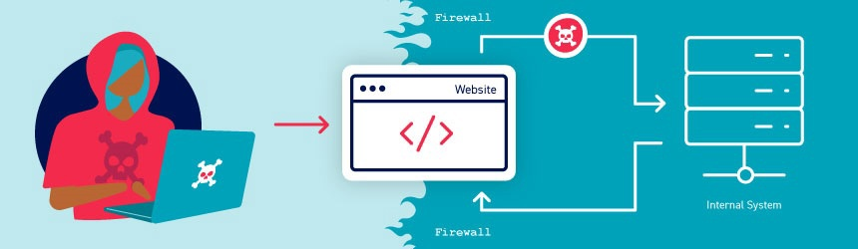

**Note**

This vulnerability is sometimes called HTTP parameter pollution. However, this term is also used to refer to a web application firewall (WAF) bypass technique. To avoid confusion, in this topic we'll only refer to server-side parameter pollution.

In addition, despite the similar name, this vulnerability class has very little in common with [server-side prototype pollution](https://portswigger.net/web-security/prototype-pollution/server-side).

## Testing for server-side parameter pollution in the query string

To test for server-side parameter pollution in the query string, place query syntax characters like #, &, and = in your input and observe how the application responds.

Consider a vulnerable application that enables you to search for other users based on their username. When you search for a user, your browser makes the following request:

GET /userSearch?name=peter&back=/home

To retrieve user information, the server queries an internal API with the following request:

GET /users/search?name=peter&publicProfile=true

### Truncating query strings

You can use a URL-encoded # character to attempt to truncate the server-side request. To help you interpret the response, you could also add a string after the # character.

For example, you could modify the query string to the following:

GET /userSearch?name=peter%23foo&back=/home

The front-end will try to access the following URL:

GET /users/search?name=peter#foo&publicProfile=true

**Note**

It's essential that you URL-encode the # character. Otherwise the front-end application will interpret it as a fragment identifier and it won't be passed to the internal API.

Review the response for clues about whether the query has been truncated. For example, if the response returns the user peter, the server-side query may have been truncated. If an Invalid name error message is returned, the application may have treated foo as part of the username. This suggests that the server-side request may not have been truncated.

If you're able to truncate the server-side request, this removes the requirement for the publicProfile field to be set to true. You may be able to exploit this to return non-public user profiles.

### Injecting invalid parameters

You can use an URL-encoded & character to attempt to add a second parameter to the server-side request.

For example, you could modify the query string to the following:

GET /userSearch?name=peter%26foo=xyz&back=/home

This results in the following server-side request to the internal API:

GET /users/search?name=peter&foo=xyz&publicProfile=true

Review the response for clues about how the additional parameter is parsed. For example, if the response is unchanged this may indicate that the parameter was successfully injected but ignored by the application.

To build up a more complete picture, you'll need to test further.

### Injecting valid parameters

If you're able to modify the query string, you can then attempt to add a second valid parameter to the server-side request.

**Related pages**

For information on how to identify parameters that you can inject into the query string, see the [Finding hidden parameters](https://portswigger.net/web-security/api-testing#finding-hidden-parameters) section.

For example, if you've identified the email parameter, you could add it to the query string as follows:

GET /userSearch?name=peter%26email=foo&back=/home

This results in the following server-side request to the internal API:

GET /users/search?name=peter&email=foo&publicProfile=true

Review the response for clues about how the additional parameter is parsed.

### Overriding existing parameters

To confirm whether the application is vulnerable to server-side parameter pollution, you could try to override the original parameter. Do this by injecting a second parameter with the same name.

For example, you could modify the query string to the following:

GET /userSearch?name=peter%26name=carlos&back=/home

This results in the following server-side request to the internal API:

GET /users/search?name=peter&name=carlos&publicProfile=true

The internal API interprets two name parameters. The impact of this depends on how the application processes the second parameter. This varies across different web technologies. For example:

* PHP parses the last parameter only. This would result in a user search for carlos.
* ASP.NET combines both parameters. This would result in a user search for peter,carlos, which might result in an Invalid username error message.
* Node.js / express parses the first parameter only. This would result in a user search for peter, giving an unchanged result.

If you're able to override the original parameter, you may be able to conduct an exploit. For example, you could add name=administrator to the request. This may enable you to log in as the administrator user.

LAB

PRACTITIONER [Exploiting server-side parameter pollution in a query string](https://portswigger.net/web-security/api-testing/server-side-parameter-pollution/lab-exploiting-server-side-parameter-pollution-in-query-string)

To solve the lab, log in as the administrator and delete carlos.

**Solution:**

1. In Burp's browser, trigger a password reset for the administrator user.
2. Notice the POST /forgot-password request and the related /static/js/forgotPassword.js JavaScript file. (code logic)
3. Send POST /forgot-password to repeater.  
   change username to invalid username like aa it gives "error":"Invalid username."  
   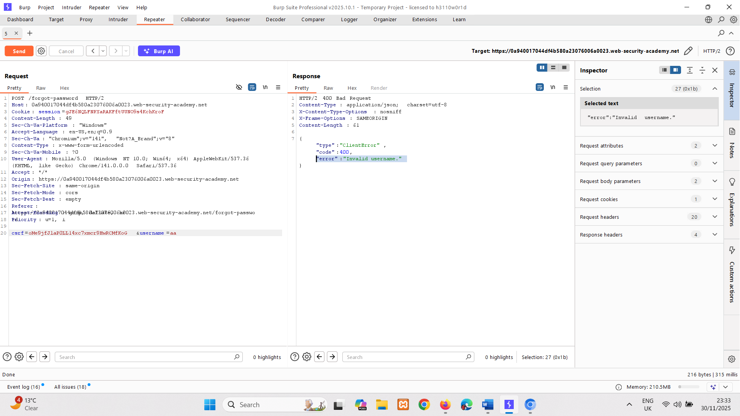
4. Try overriding username parameter.  
   add username carlos too  
   username=administrator%26username=carlos  
   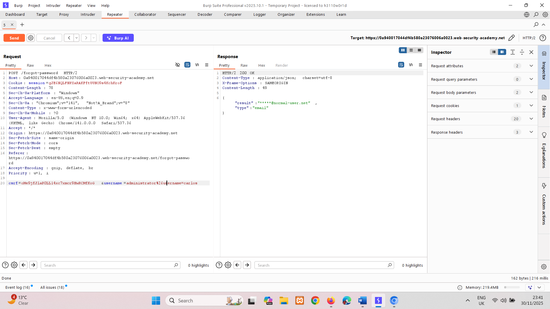  
   But we don’t know for which user it is sending result cause email is not visible.
5. For %26 giving "error": "Parameter is not supported.  
   Try username=administrator%23test  
     
   To find field notice that   
   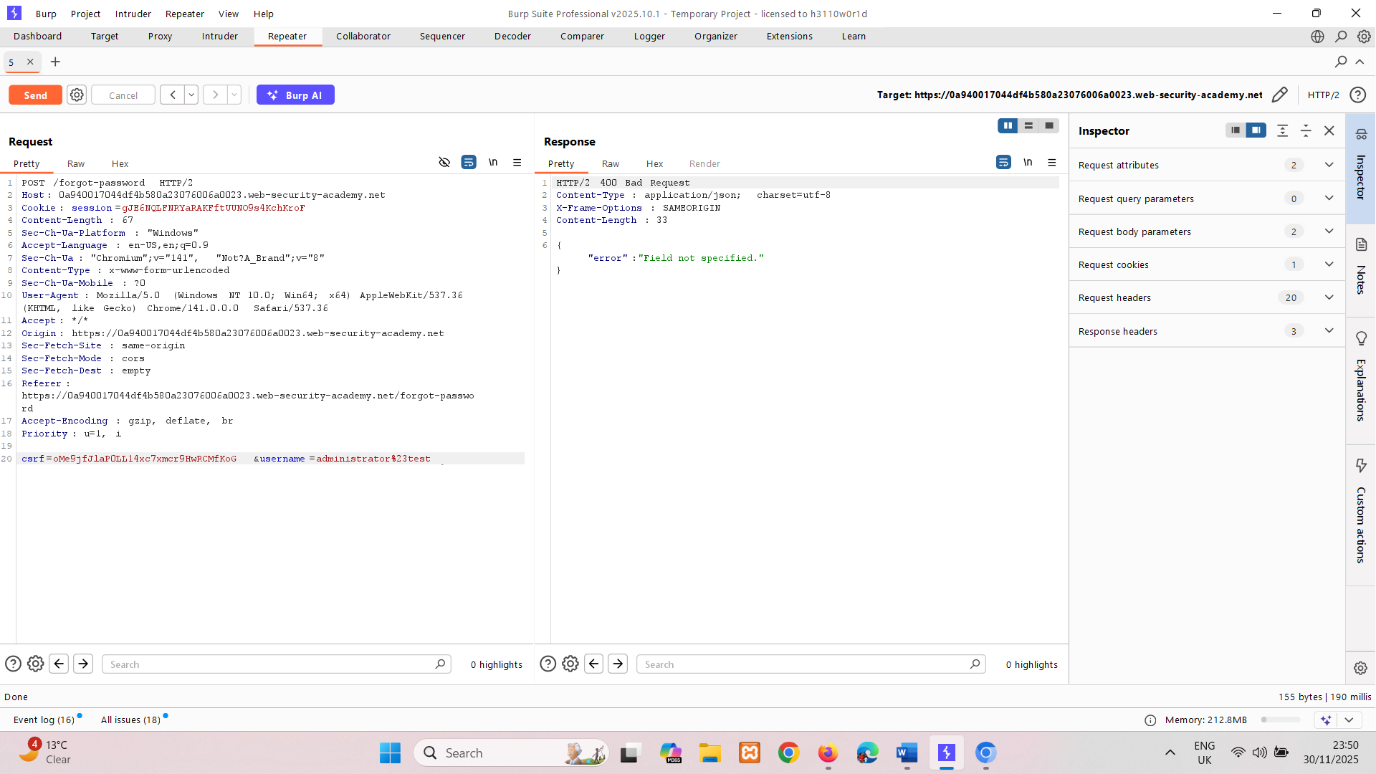  
   It is truncating it but giving error -> "error": "Field not specified."  
     
   So change it to   
   username=administrator%26field=123  
   giving -> "error":"Invalid field."   
     
   To find field name can try list of fields in intruder -> server side variable names  
   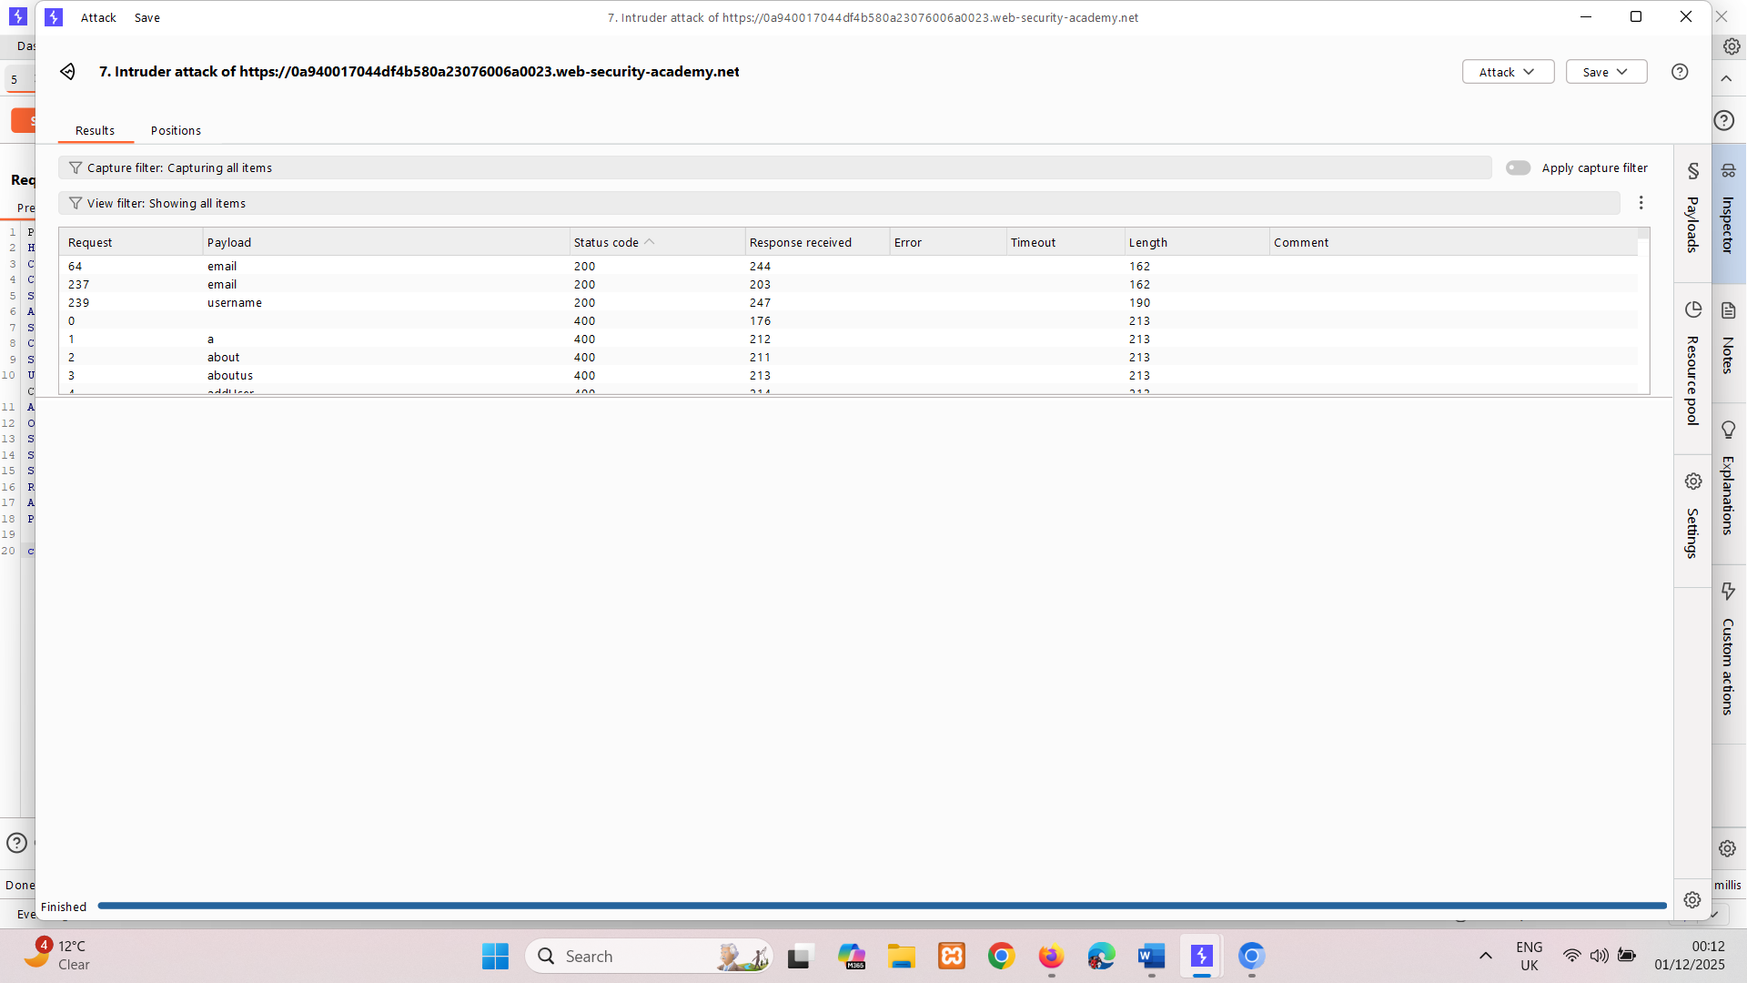  
   it giving only email and username field which gives non useful results

{"result":"*****@normal-user.net","type":"email"}  
  
{"result":"administrator","type":"username"}

1. Notice in code we have reset_token parameter try with it.  
   /forgot-password?reset_token=${resetToken}  
   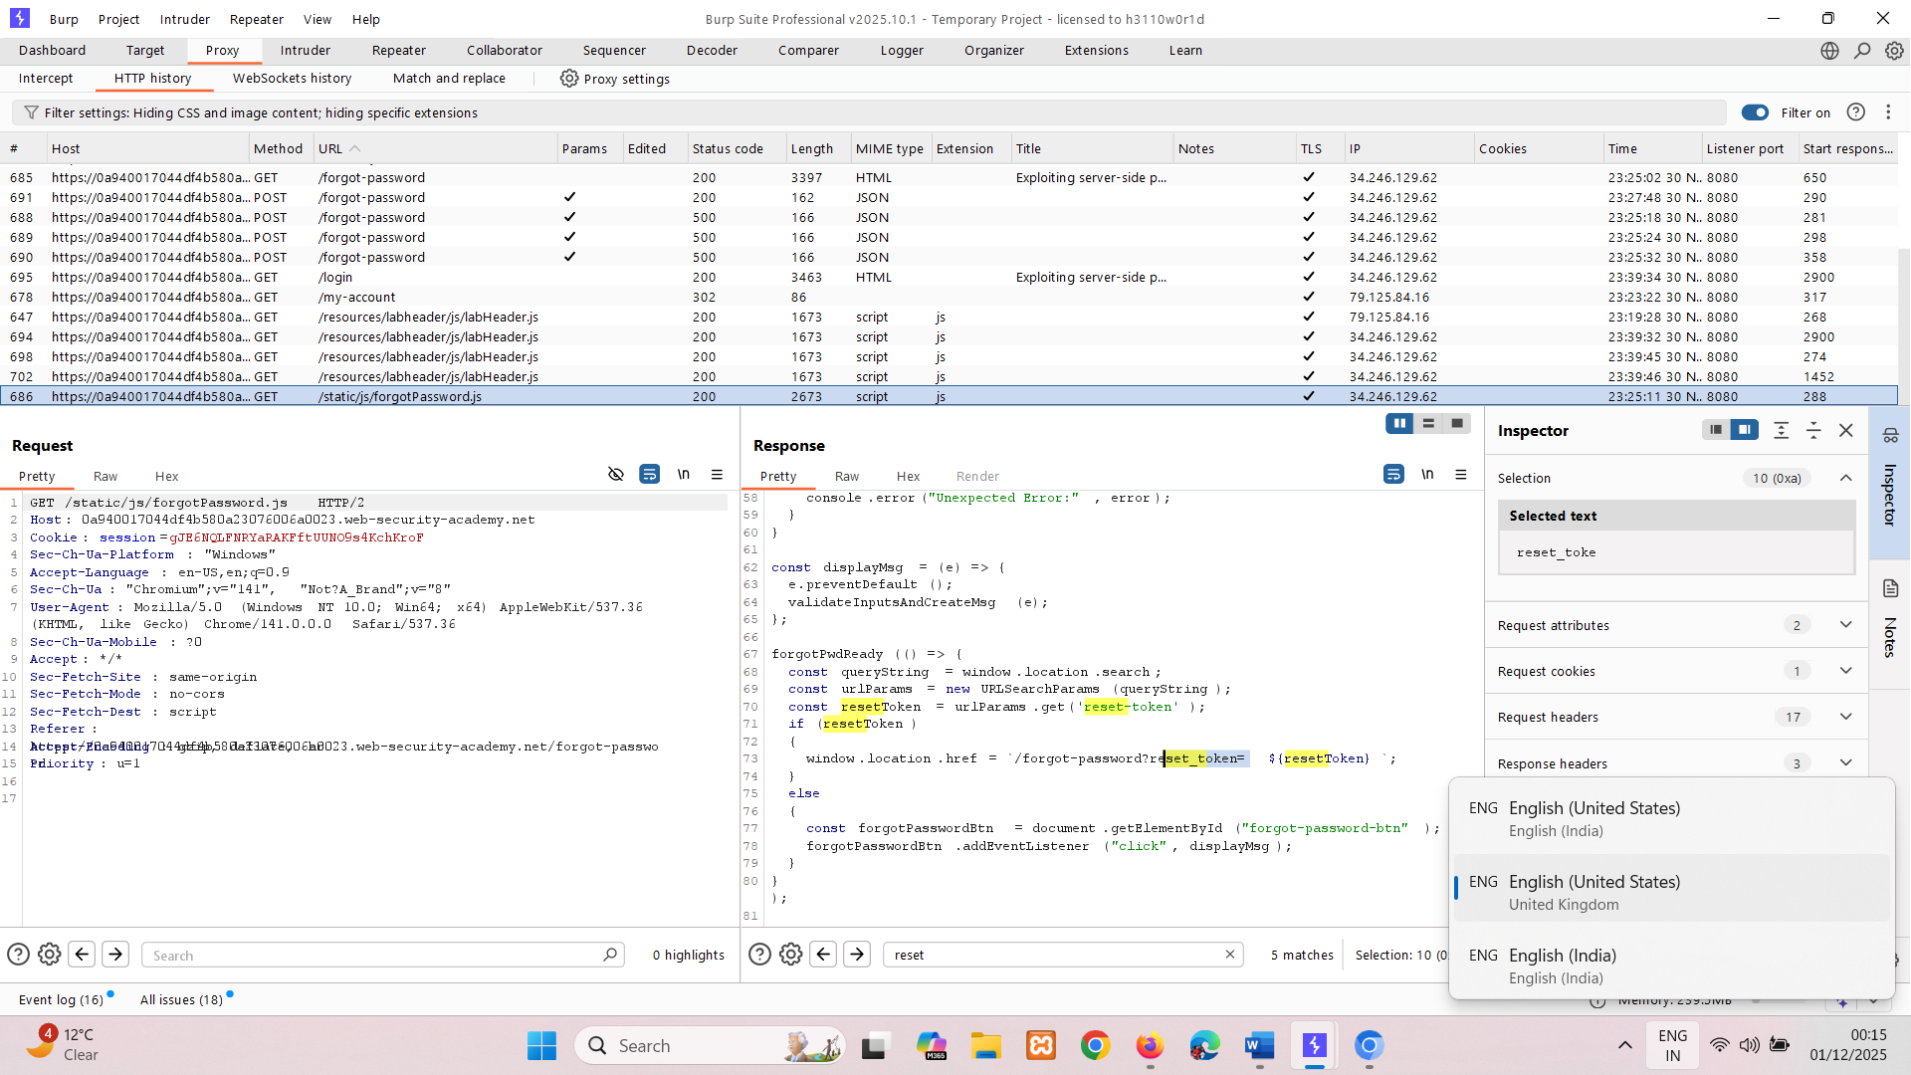

And there is it, we’re getting token value copy it. qdiqg0vg15m58qmyi7ykxte65zdn7qip

1. In browser, enter the password reset endpoint in the address bar. Add your password reset token as the value of the reset_token parameter.

/forgot-password?reset_token=qdiqg0vg15m58qmyi7ykxte65zdn7qip

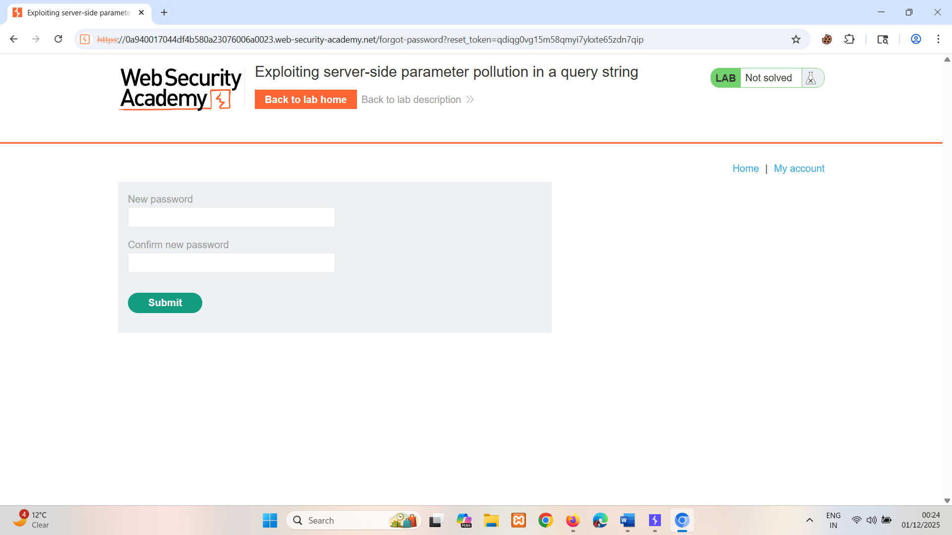

It is redirecting to new password   
Enter new password.

1. Login with new password and delete user carlos.

## Testing for server-side parameter pollution in REST paths

A RESTful API may place parameter names and values in the URL path, rather than the query string. For example, consider the following path:

/api/users/123

The URL path might be broken down as follows:

* /api is the root API endpoint.
* /users represents a resource, in this case users.
* /123represents a parameter, here an identifier for the specific user.

Consider an application that enables you to edit user profiles based on their username. Requests are sent to the following endpoint:

GET /edit_profile.php?name=peter

This results in the following server-side request:

GET /api/private/users/peter

An attacker may be able to manipulate server-side URL path parameters to exploit the API. To test for this vulnerability, add path traversal sequences to modify parameters and observe how the application responds.

You could submit URL-encoded peter/../admin as the value of the name parameter:

GET /edit_profile.php?name=peter%2f..%2fadmin

This may result in the following server-side request:

GET /api/private/users/peter/../admin

If the server-side client or back-end API normalize this path, it may be resolved to /api/private/users/admin.

LAB

EXPERT [Exploiting server-side parameter pollution in a REST URL](https://portswigger.net/web-security/api-testing/server-side-parameter-pollution/lab-exploiting-server-side-parameter-pollution-in-rest-url)

To solve the lab, log in as the administrator and delete carlos.

**Solution:**

### Study the behavior

1. In browser, trigger a password reset for the administrator user.

Notice the POST /forgot-password request and the related /static/js/forgotPassword.js JavaScript file. (js file -> has passwordResetToken)

1. Send POST /forgot-password request to Repeater.

Resend the request to confirm that the response is consistent.

1. Send a variety of requests with a modified username parameter value to determine whether the input is placed in the URL path of a server-side request without escaping:

* Submit URL-encoded administrator# as the value of the username parameter.  
  Notice that this returns an Invalid route error message. This suggests that the server may have placed the input in the path of a server-side request, and that the fragment has truncated some trailing data. Observe that the message also refers to an API definition.   
  O/P ->

{   
 "type": "error",  
 "result": "Invalid route. Please refer to the API definition"  
 }

* Change the value of the username parameter from administrator%23 to URL-encoded administrator?, then send the request.

Notice that this also returns an Invalid route error message. This suggests that the input may be placed in a URL path, as the ? character indicates the start of the query string and therefore truncates the URL path. O/P ->

{  
 "type": "error",  
 "result": "Invalid route. Please refer to the API definition"

}

* Change the value of the username parameter from administrator%3F to ./administrator then send the request.

Notice that this returns the original response. This suggests that the request may have accessed the same URL path as the original request. This further indicates that the input may be placed in the URL path. O/P ->  
{"result":"*****@normal-user.net","type":"email"}

* Change the value of the username parameter from ./administrator to ../administrator, then send the request.  
  Notice that this returns an Invalid route error message. This suggests that the request may have accessed an invalid URL path. O/P ->  
  {"type": "error", "result": "Invalid route. Please refer to the API definition"}

## Navigate to the API definition

1. Change the value of the username parameter from ../administrator to ../%23. Notice the Invalid route response. O/P ->  
   {"type": "error", "result": "Invalid route. Please refer to the API definition"}
2. Incrementally add further ../ sequences until you reach ../../../../%23 Notice that this returns a Not found response. This indicates that you've navigated outside the API root. O/P ->  
   { "error": "Unexpected response from API server:\n<html>\n<head>\n   
   <meta charset=\"UTF-8\">\n   
   <title>Not Found<\/title>\n<\/head>\n  
   <body>\n   
   <h1>Not found<\/h1>\n  
   <p>The URL that you requested was not found.<\/p>\n  
   <\/body>\n<\/html>\n"

}

1. At this level, add some common API definition filenames to the URL path. For example, submit the following:

username=../../../../openapi.json%23

Notice that this returns an error message, which contains the following API endpoint for finding users:

/api/internal/v1/users/{username}/field/{field}

Notice that this endpoint indicates that the URL path includes a parameter called field.   
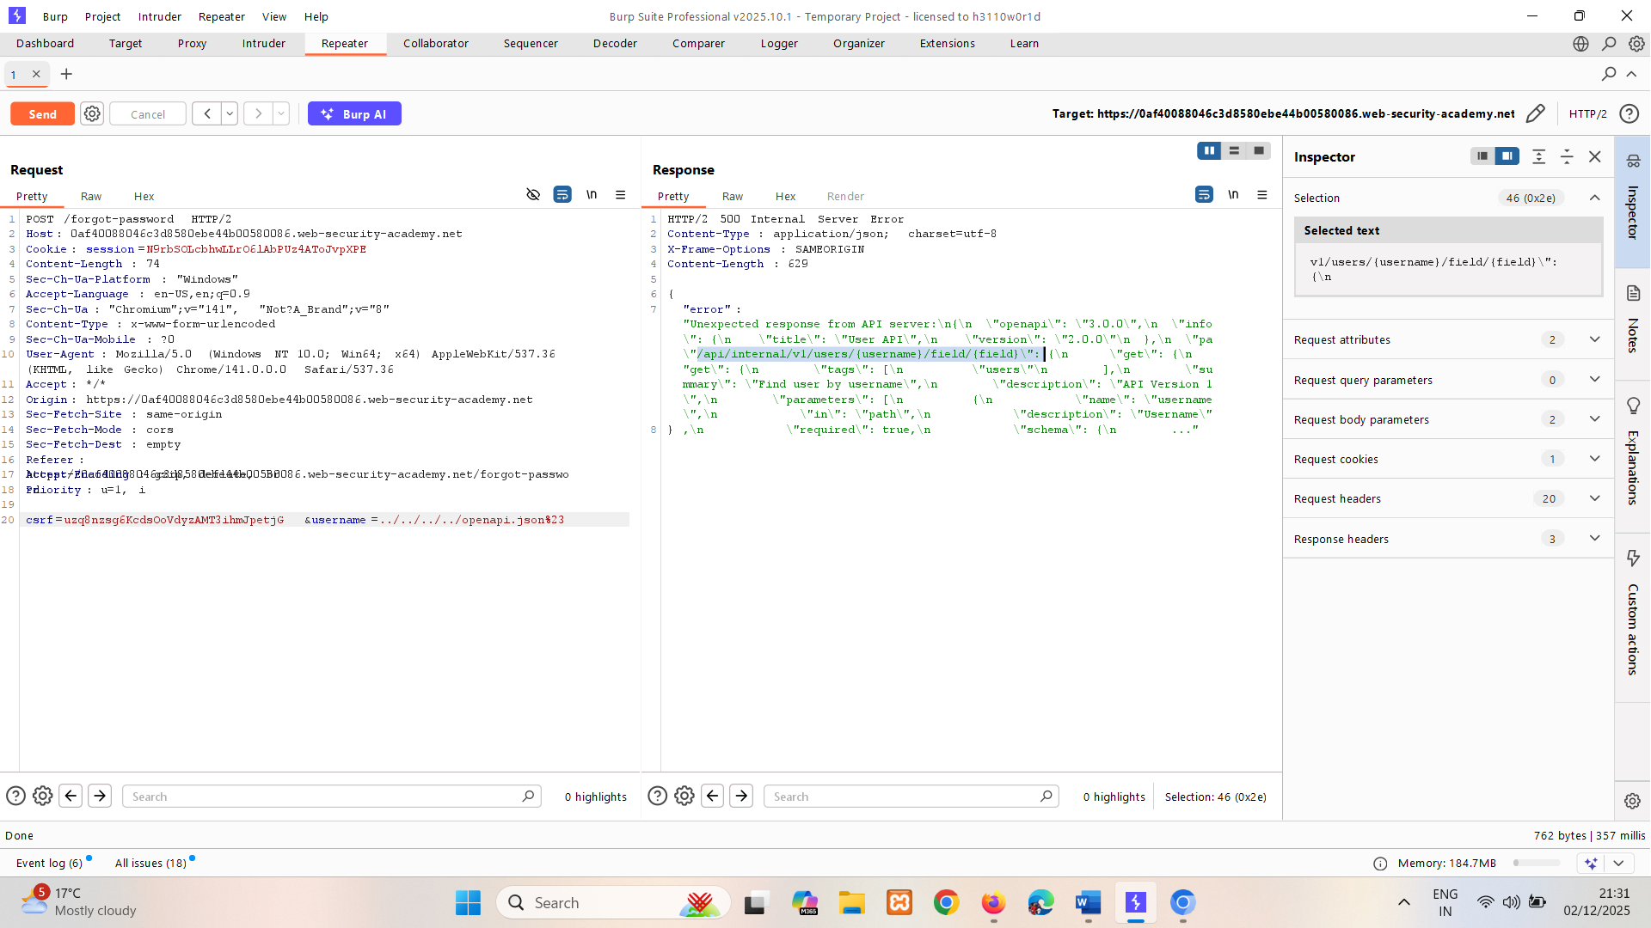

## Exploit the vulnerability

1. Update the value of the username parameter, using the structure of the identified endpoint. Add an invalid value for the field parameter:

username=administrator/field/foo%23

Send the request. Notice that this returns an error message, because the API only supports the email field.   
  
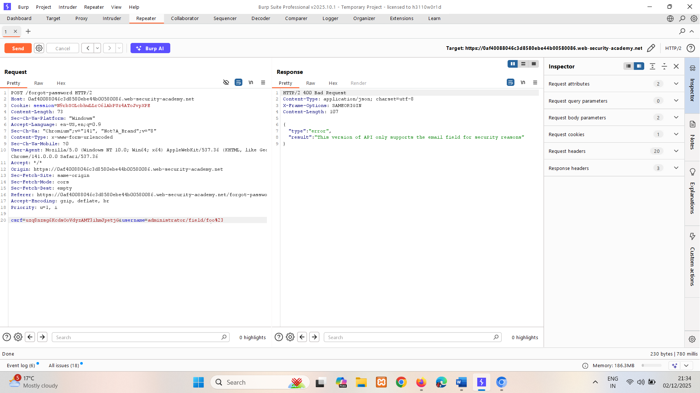

1. Add email as the value of the field parameter:

username=administrator/field/email%23

Send the request. Notice that this returns the original response. This may indicate that the server-side application recognizes the injected field parameter and that email is a valid field type.   
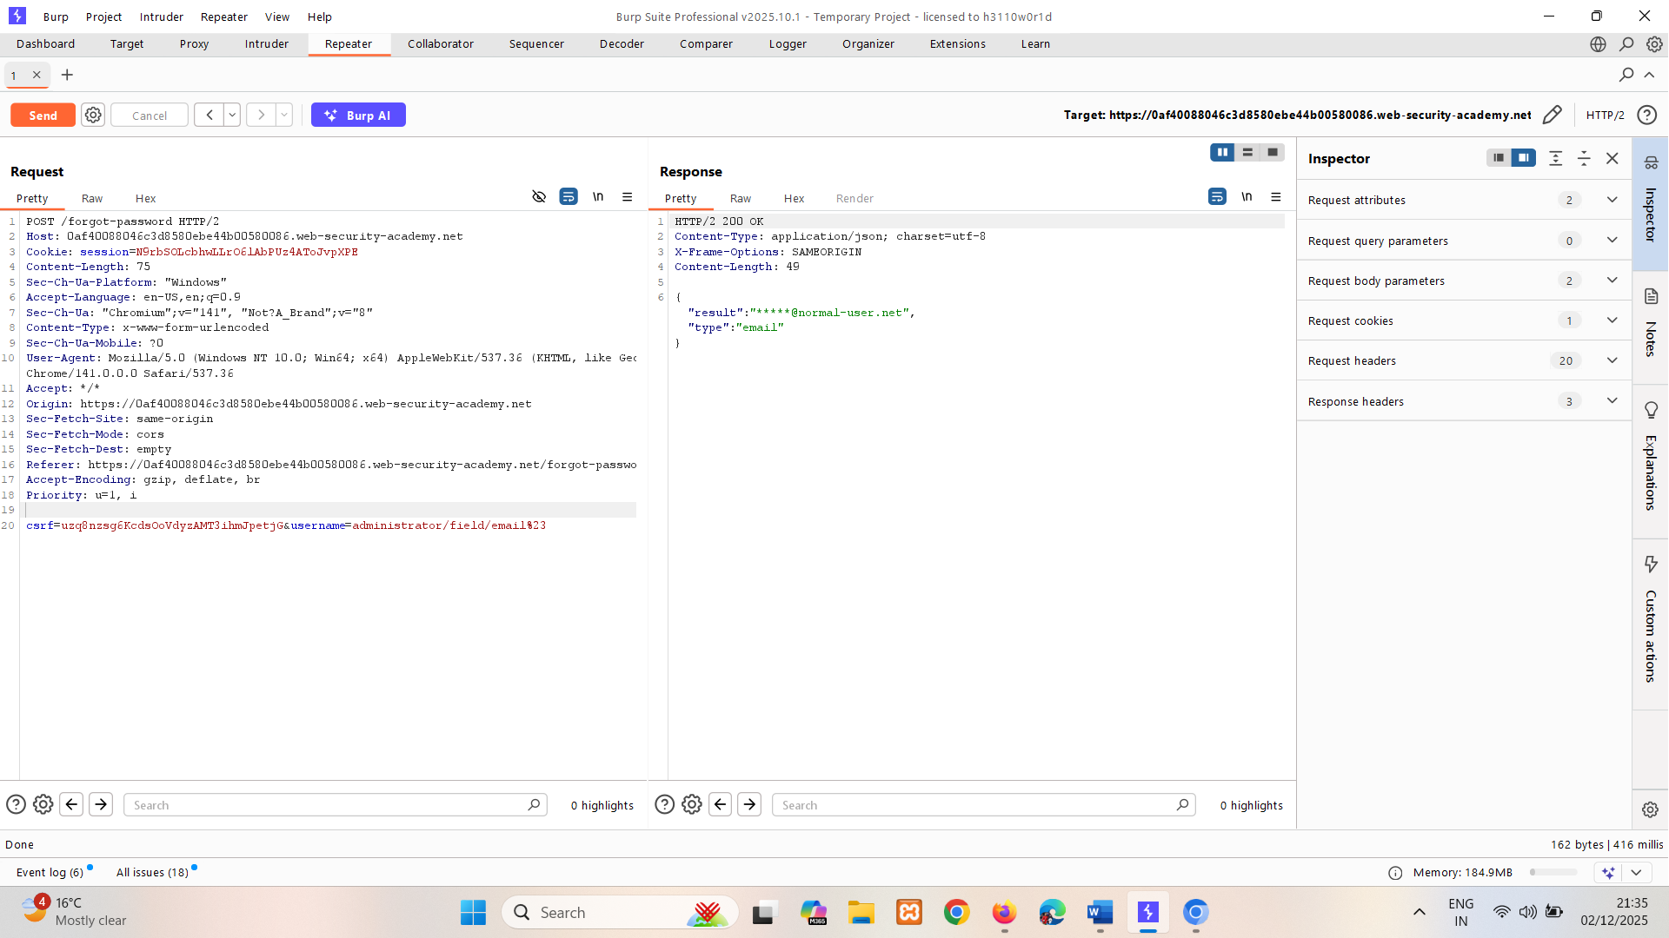

1. Review the /static/js/forgotPassword.js JavaScript file. Identify the password reset endpoint, which refers to the passwordResetToken parameter:

/forgot-password?passwordResetToken=${resetToken}   
  
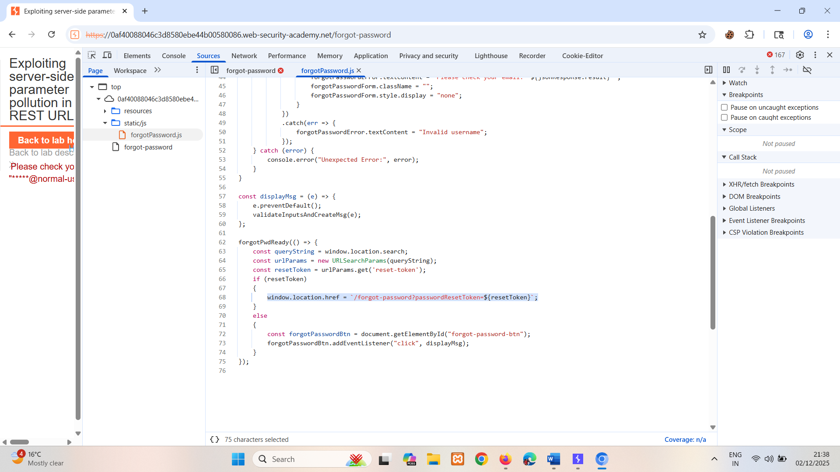

1. In the **Repeater** tab, change the value of the field parameter from email to passwordResetToken:

username=administrator/field/passwordResetToken%23

Send the request. Notice that this returns an error message, because the passwordResetToken parameter is not supported by the version of the API that is set by the application.   
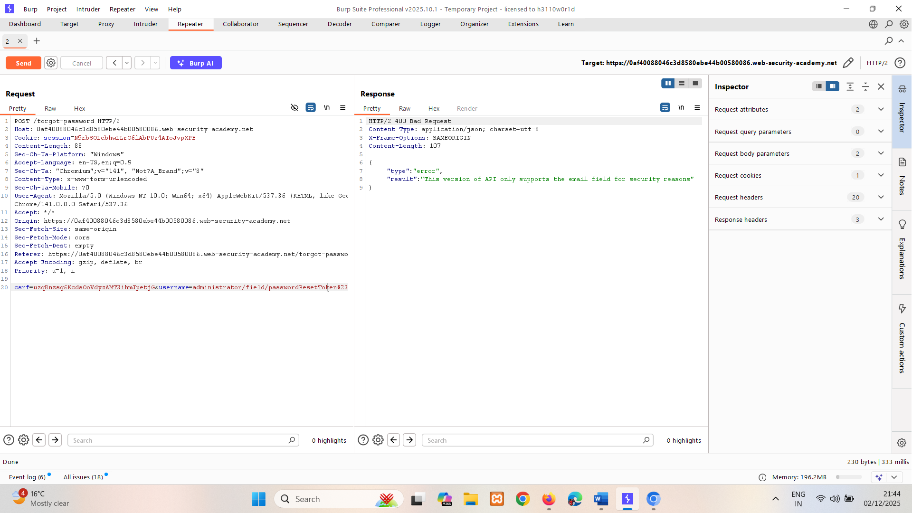

1. Using the /api/ endpoint that you identified earlier, change the version of the API in the value of the username parameter:

username=../../v1/users/administrator/field/passwordResetToken%23

Send the request. Notice that this returns a password reset token. Make a note of this.   
  
  
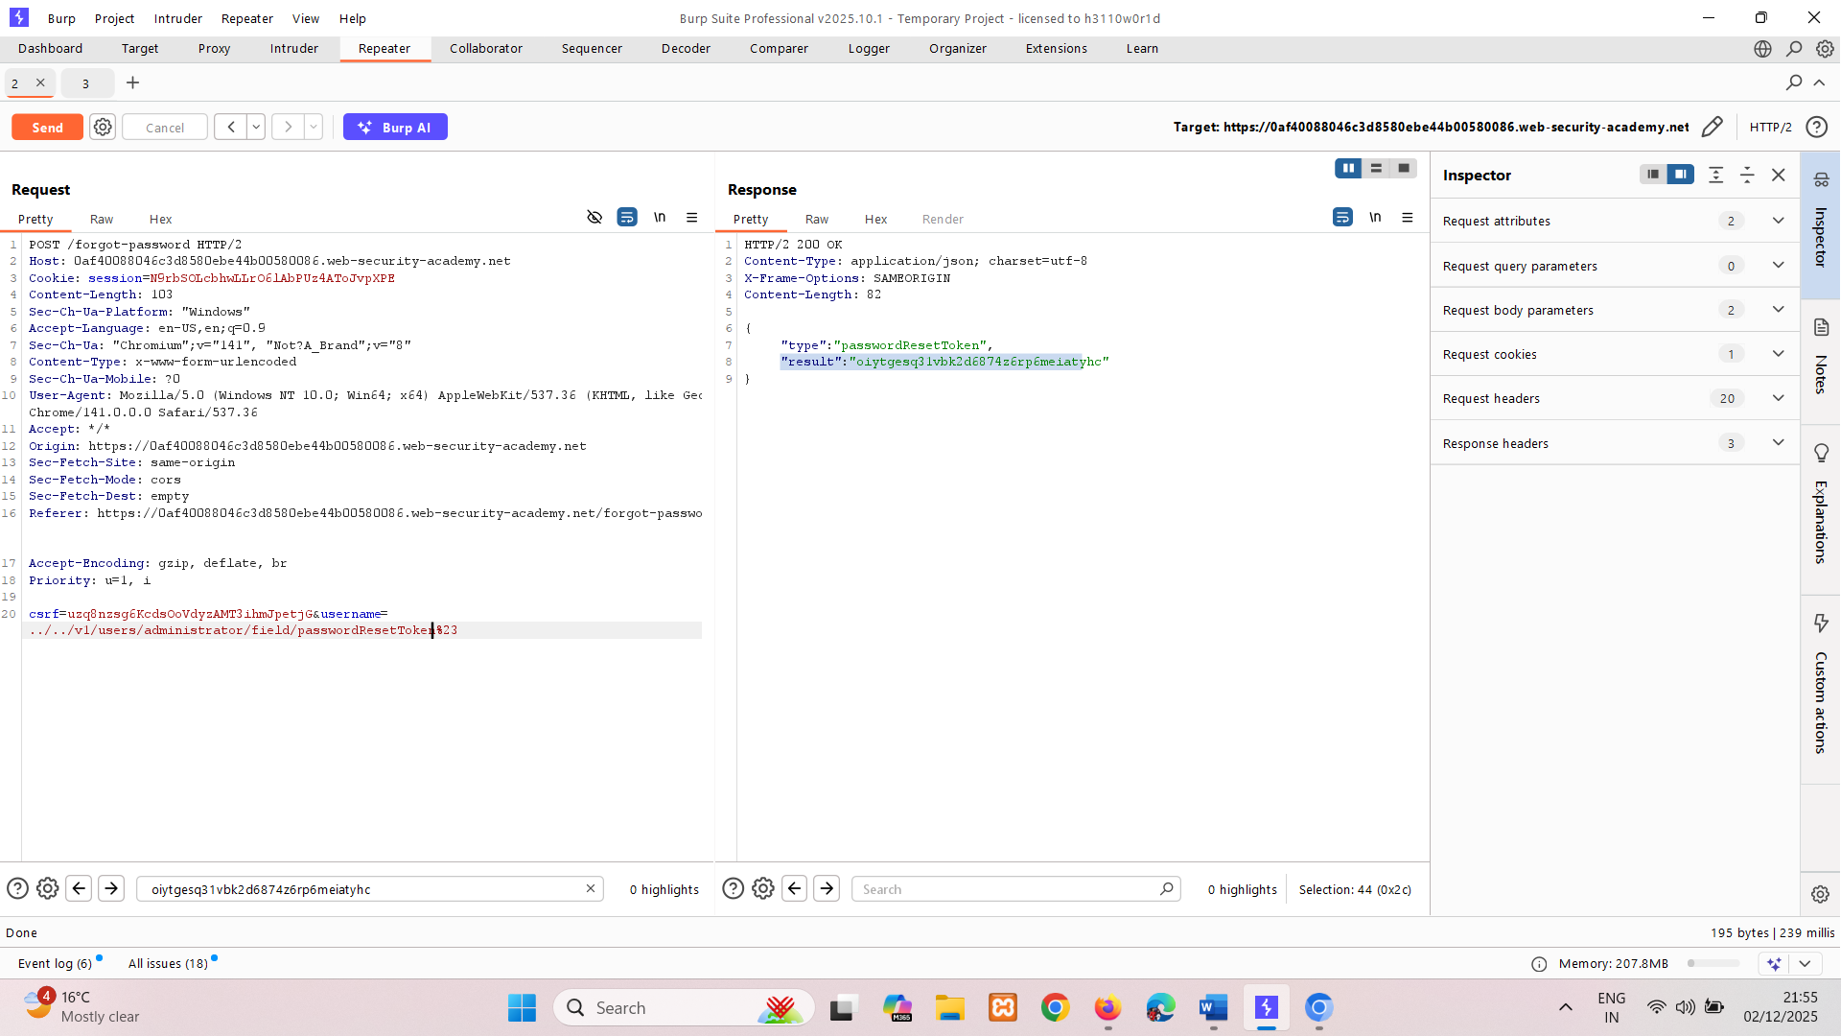

1. Send GET /forgot-password to repeater and change url to:

/forgot-password?passwordResetToken=oiytgesq31vbk2d6874z6rp6meiatyhc

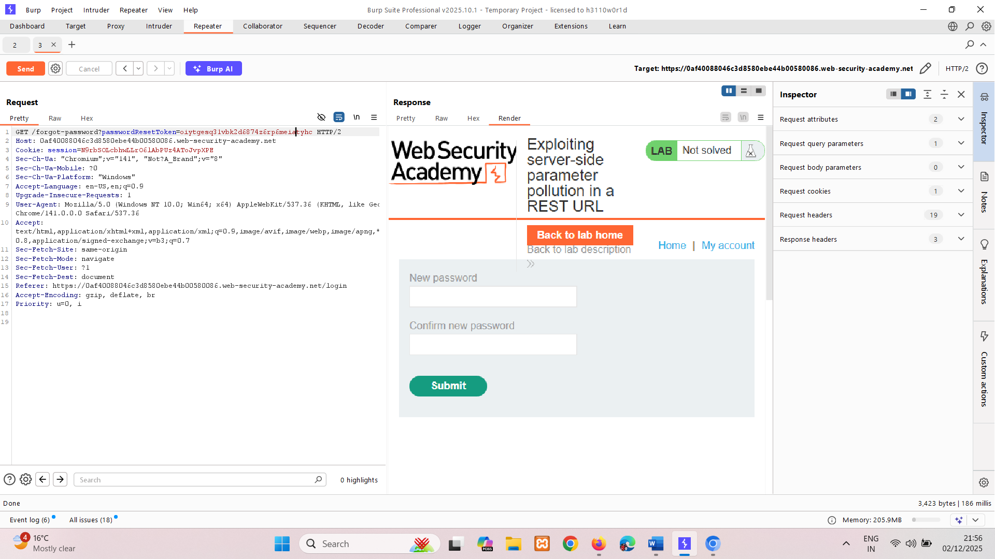  
Do Show response in browser.

1. Set a new password.

Log in as the administrator using your password.

Go to the **Admin panel** and delete carlos.

## Testing for server-side parameter pollution in structured data formats

An attacker may be able to manipulate parameters to exploit vulnerabilities in the server's processing of other structured data formats, such as a JSON or XML. To test for this, inject unexpected structured data into user inputs and see how the server responds.

Consider an application that enables users to edit their profile, then applies their changes with a request to a server-side API. When you edit your name, your browser makes the following request:

POST /myaccount   
name=peter

This results in the following server-side request:

PATCH /users/7312/update   
{"name":"peter"}

You can attempt to add the access_level parameter to the request as follows:

POST /myaccount   
name=peter","access_level":"administrator

If the user input is added to the server-side JSON data without adequate validation or sanitization, this results in the following server-side request:

PATCH /users/7312/update   
{name="peter","access_level":"administrator"}

This may result in the user peter being given administrator access.

**Related pages**

For information on how to identify parameters that you can inject into the query string, see the [Finding hidden parameters](https://portswigger.net/web-security/api-testing#finding-hidden-parameters) section.

Consider a similar example, but where the client-side user input is in JSON data. When you edit your name, your browser makes the following request:

POST /myaccount   
{"name": "peter"}

This results in the following server-side request:

PATCH /users/7312/update   
{"name":"peter"}

You can attempt to add the access_level parameter to the request as follows:

POST /myaccount   
{"name": "peter\",\"access_level\":\"administrator"}

If the user input is decoded, then added to the server-side JSON data without adequate encoding, this results in the following server-side request:

PATCH /users/7312/update   
{"name":"peter","access_level":"administrator"}

Again, this may result in the user peter being given administrator access.

Structured format injection can also occur in responses. For example, this can occur if user input is stored securely in a database, then embedded into a JSON response from a back-end API without adequate encoding. You can usually detect and exploit structured format injection in responses in the same way you can in requests.

**Note**

This example below is in JSON, but server-side parameter pollution can occur in any structured data format. For an example in XML, see the [XInclude attacks](https://portswigger.net/web-security/xxe#xinclude-attacks) section in the XML external entity (XXE) injection topic.

## Testing with automated tools

Burp includes automated tools that can help you detect server-side parameter pollution vulnerabilities.

Burp Scanner automatically detects suspicious input transformations when performing an audit. These occur when an application receives user input, transforms it in some way, then performs further processing on the result. This behavior doesn't necessarily constitute a vulnerability, so you'll need to do further testing using the manual techniques outlined above. For more information, see the [Suspicious input transformation](https://portswigger.net/kb/issues/00400d00_suspicious-input-transformation-reflected) issue definition.

You can also use the Backslash Powered Scanner BApp to identify server-side injection vulnerabilities. The scanner classifies inputs as boring, interesting, or vulnerable. You'll need to investigate interesting inputs using the manual techniques outlined above. For more information, see the [Backslash Powered Scanning: hunting unknown vulnerability classes](https://portswigger.net/research/backslash-powered-scanning-hunting-unknown-vulnerability-classes) whitepaper.

## Preventing server-side parameter pollution

To prevent server-side parameter pollution, use an allowlist to define characters that don't need encoding, and make sure all other user input is encoded before it's included in a server-side request. You should also make sure that all input adheres to the expected format and structure.

# Web Security Academy alignment with the OWASP Top 10 API vulnerabilities

The OWASP Foundation periodically publishes a list of critical API-specific security risks. Although some of these risks have a different name in the context of APIs, many of them align with our existing Web Security Academy topics.

The table below specifies which Web Security Academy topics are relevant to the OWASP Top 10 API vulnerabilities:

|  |  |
| --- | --- |
| **Risk** | **Relevant Web Security Academy topics** |
| Broken object level authorization | [Access control vulnerabilities and privilege escalation](https://portswigger.net/web-security/access-control) |
| Broken authentication | [Authentication vulnerabilities](https://portswigger.net/web-security/authentication)  [OAuth 2.0 authentication vulnerabilities](https://portswigger.net/web-security/oauth)  [JWT attacks](https://portswigger.net/web-security/jwt) |
| Broken object property level authorization | [Mass assignment vulnerabilities](https://portswigger.net/web-security/api-testing#mass-assignment-vulnerabilities) |
| Unrestricted resource consumption | [Race conditions](https://portswigger.net/web-security/race-conditions)  [File upload vulnerabilities](https://portswigger.net/web-security/file-upload) |
| Broken function level authorization | [Access control vulnerabilities and privilege escalation](https://portswigger.net/web-security/access-control) |
| Unrestricted access to sensitive business flows | [Business logic vulnerabilities](https://portswigger.net/web-security/logic-flaws) |
| Server side request forgery | [Server-side request forgery (SSRF)](https://portswigger.net/web-security/ssrf) |
| Security misconfiguration | [Cross-origin resource sharing (CORS)](https://portswigger.net/web-security/cors)  [Information disclosure vulnerabilities](https://portswigger.net/web-security/information-disclosure)  [HTTP Host header attacks](https://portswigger.net/web-security/host-header)  [HTTP request smuggling](https://portswigger.net/web-security/request-smuggling) |
| Improper inventory management | [API testing](https://portswigger.net/web-security/api-testing) |
| Unsafe consumption of APIs | [API testing](https://portswigger.net/web-security/api-testing) |

You can read more about the OWASP API Top 10 on the OWASP website, at [OWASP API Security Top 10 - 2023](https://owasp.org/API-Security/editions/2023/en/0x00-header/).